PCR Email Templates
2010

Billboard
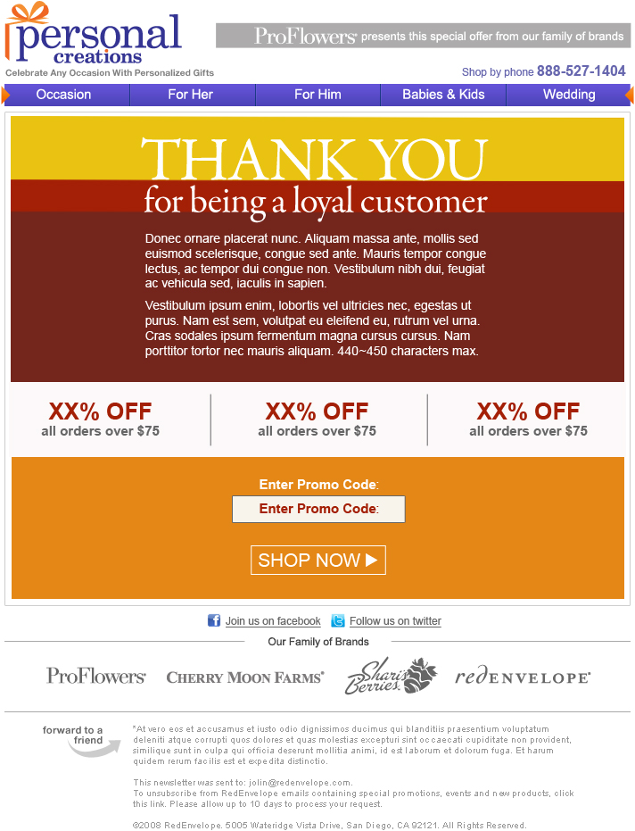
BillboardPromoCode.CodeColor
BillboardPromoCode.BackgroundColor
BottomBar.TextColor
BottomBar.Text

Text.BackgroundColor
BillboardShopNowBox.TextColor
BillboardShopNowBox.BackgroundColor
Border: BillboardShopNowBox.TextColor
Text.BodyCopy
BottomBanner.AltText
BottomBanner.ImageName
BottomBar.BackgroundColor

PromoCode.Code
OfferTier.BackgroundColor
GraphicTextTile.ImageName
Text.BackgroundColor2
Category
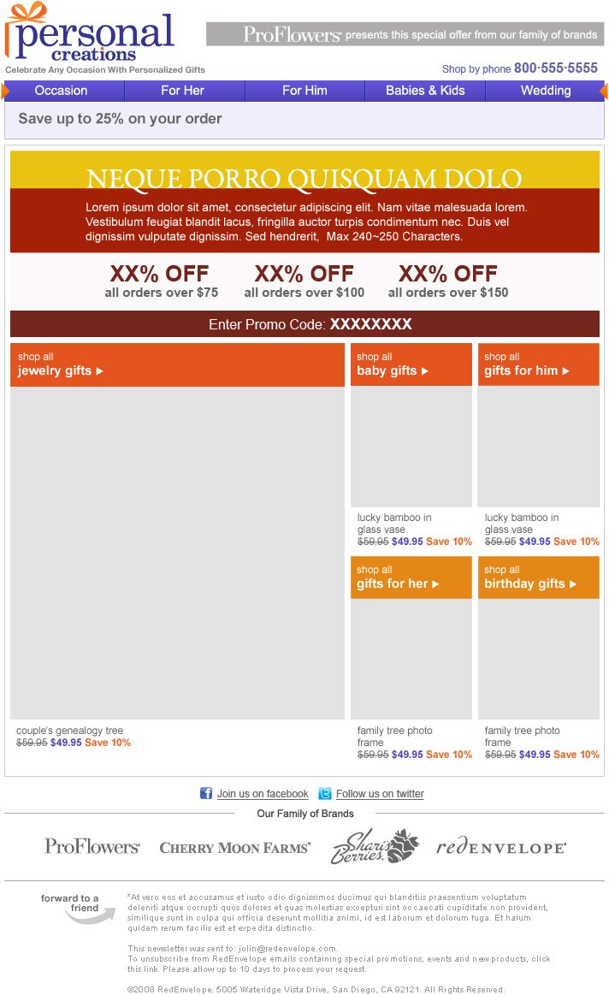
Header.CategoryColor
ProductHero.CategoryName
Product#.CategoryName
Text.Subhead
GraphicTextTile.ImageName
Header.LeadCopy

Deal Of The Day
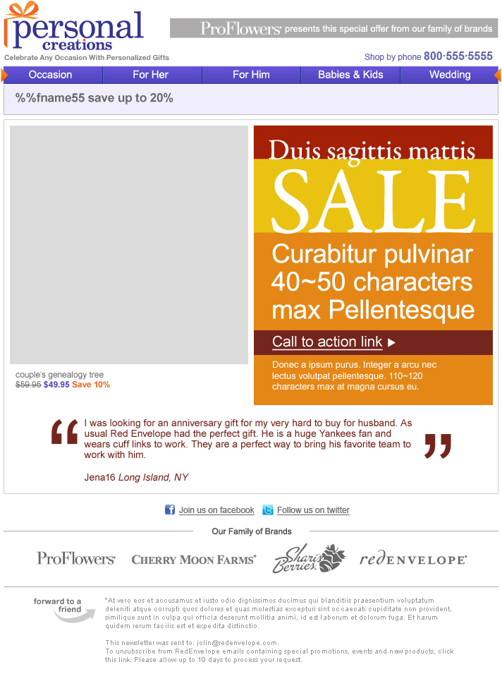
GraphicTextTile.ImageName
Header.LeadCopy
Text.LinkTextBackgroundColor
Text.BackgroundColor
Text.BodyCopy
Text.LinkText
Text.Subhead

Hero
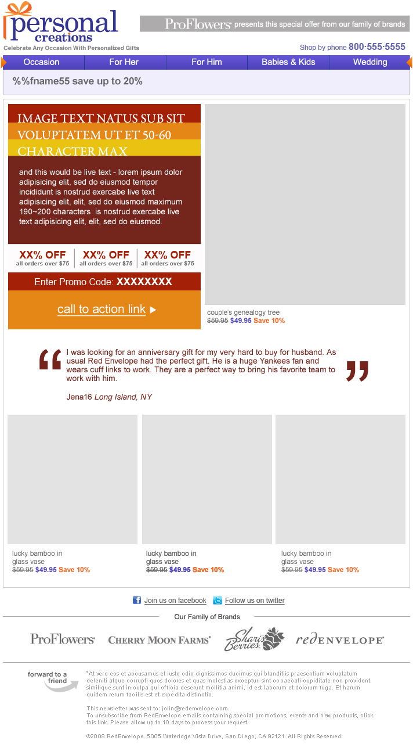
Testimonial.Location
Testimonial.Author
Testimonial.QuoteImageClose
Testimonial.Quote
Testimonial.QuoteImageOpen
Lifestyle Billboard
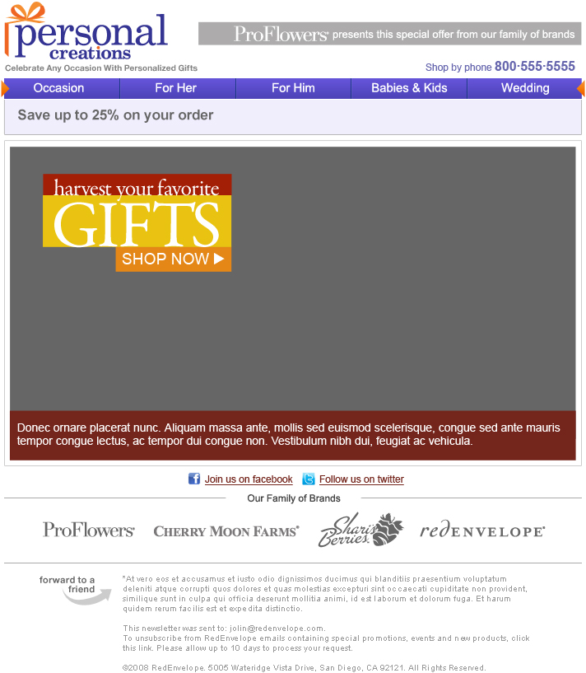
GraphicTextTile.ImageName
Text.BodyCopy

NCO
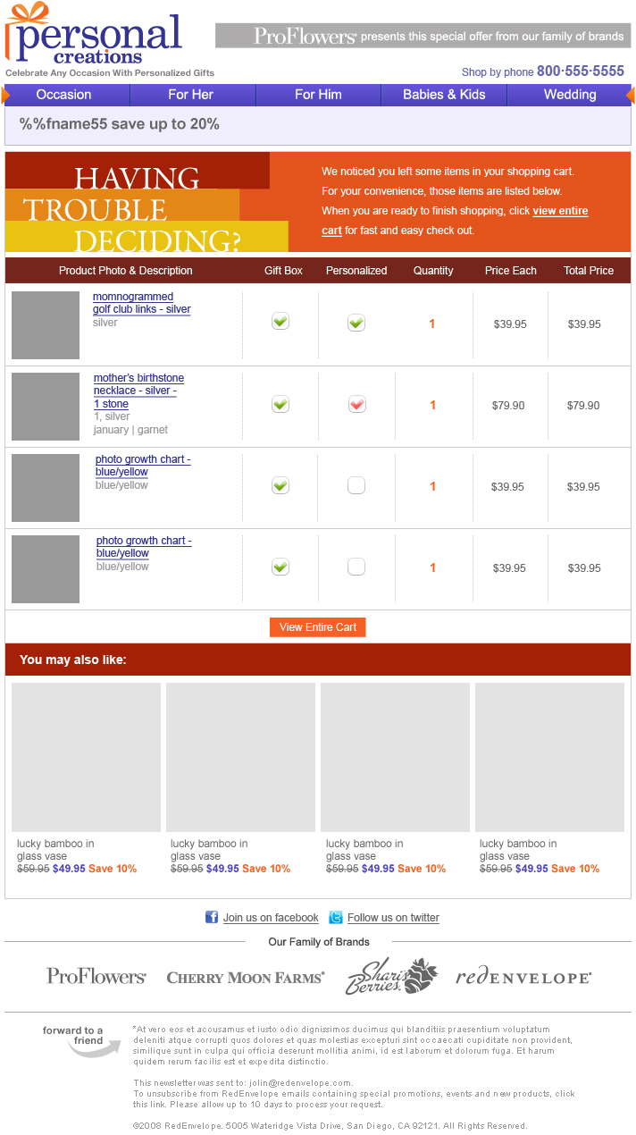

Recovery Zone
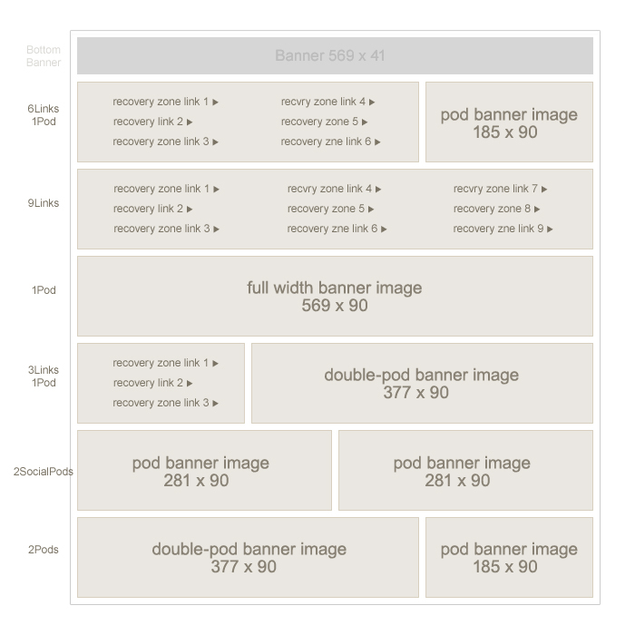

Recovery Zone Gen2
